Foundation for Virtual and Augmented Reality Systems
Prof. Samit Bhattacharya
Department of Computer Science and Engineering
Indian Institute of Technology, Guwahati
Week – 03
Lecture – 13
Lec 13: VR Hardware
Hello and welcome to the NPTEL MOOCs course on Foundations for Virtual and Augmented Reality Systems. We are going to start lecture number 7 on VR Hardware. As per the convention we are following, before we start we are going to briefly talk about what we have covered so far and what we are going to cover in this lecture. So, so far we have covered basic things related to the basic idea, what is VR, what is AR, what is XR, the definitions, what these terms precisely mean, their historical evolution in brief and some issues and challenges that are of major concern for those dealing with these technology areas. In this lecture, whatever we have covered so far are part of introductory concepts. Now, we are going to get into more details on the actual technologies. So, in this lecture, we are going to get introduced to the hardware components, hardware components used for VR experience. Now, when we use the term hardware, the first step to understand the hardware used for VR is to first understand how VR works.
In other words, we need to first understand or consider what constitutes the entire VR system. So, when we are talking of the experience that is psychological, however the experience comes from a setup, a system. Now, what is that system? Generally, our understanding is that system means a combination of hardware and software only. And in this context, we can say that the prevalent view is that whenever we are using the term VR setup or VR system, that is merely the hardware components such as computers, headsets, and controllers. So, that is the whole VR system. But this view may not necessarily be the correct way of looking at what a VR system is. Now let us have a look at this overall schematic view of a system, a VR system. So, it contains several components and data flow between components.
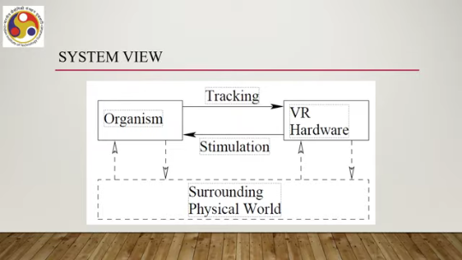
So, it has got one component called organism, one component called VR hardware, and one component called the surrounding physical world. We can also see that from organism there is a data flow to the VR hardware which is labeled as tracking. Similarly, from VR hardware, data flows to organism component which is labeled as stimulation. There are data flows between VR hardware and surrounding physical world as shown with these dotted arrows, bidirectional dotted arrows. Bidirectional data flow happens between surrounding physical world and the organism components as illustrated here.
So, this is what we can call a complete view of a VR system rather than only one component that is the hardware part as mentioned or shown in this schematic. So, what does it tell? It tells that it is equally important to account for the other components, notably the organism component along with the hardware component, when we are considering the VR system. Now, in our context, typically the organism refers to the human user. So, since the user is always there. So, we cannot avoid the user component of the overall system; we cannot only concentrate on the hardware component. Now, let us try to understand the data flow between these components: organism and hardware. The hardware produces stimuli that override the senses of the user. So, essentially that is referred to in this schematic diagram as stimulation data flow.
The tracking data flow indicates that tracking is needed to adjust stimulus based on human motions. And in order to perform tracking, we require sensors that track user motions. So, what they say in summary is that there is bidirectional data flow between the hardware part and the organism part of the overall VR system. So, trackers or sensors are used to track the organism or user motions and hardware generates stimuli which are sent to the organism to stimulate the user's senses.
That part is indicated here using the labeled arrow where the label is stimulation. Now, when we are talking about tracking, the most important thing to track is head tracking which is commonly used in VR: head tracking. However, that is not the only thing we can track. Tracking may also include other things such as button presses.
So, we need to track which button is pressed in which context, controller movements, eye movements, movements of other body parts. So, all these things: button presses, controller movements, eye movements, other body parts movement - all these things may be tracked along with head movement. But that is not the whole story. Along with the VR hardware part and the VR user part.
We should also take into account, as part of the system, the surrounding physical world. Why is that so? It is quite likely that the user may respond to stimuli coming from the real world. So, we cannot completely, or we may not be able to completely, detach the user from the real world.
Some stimuli, say for example, some light, sound, some smell - all these things may come and may change user's behavior. So, the user may respond to those stimuli coming from the real world which may change user behavior. So, we should be aware of the surroundings. The user may also change the environment through motion, physical environment. So, when the user is interacting with the virtual world, some physical movement may take place which may change user's environment.
So, it cannot be oblivious to the fact that some changes may happen to the user's environment and environment may affect behavior of the user while interacting with the virtual world. So, that should also be considered as part of the VR system. Also, the hardware may track objects other than the users. So, earlier we said that the VR hardware part includes trackers or sensors to track users' head movement and other activities.
Hardware may also be used or there can be trackers as part of the hardware which can track objects in the surroundings rather than the user directly. Now, that is required especially if interaction with those objects is part of the experience. And the hardware that we are trying to understand may also change the environment which in effect may change the user behavior. How can it change? Say, for example, we are trying to use an immersive application to control a robotic arm.
Now, the arm may change objects in the environment by changing their position. So, that is affecting the environment and that is part that we may consider as part of the VR hardware. So, it is not that hardware is only dealing with the user, it is also possible that the hardware is dealing with the objects surrounding the user, the objects that are part of the surrounding physical environment. So, when we consider VR hardware, we should not restrict our understanding of hardware to only the computer or HMD or the controller used by the user. We should have a holistic view. We should understand that the overall VR system has three components: the user, the hardware, and the environment. The hardware can be used to control the environment along with using along with being used to let the user provide input and let the user perceive the virtual world. So, whatever we have discussed so far, based on that we can summarize the major components of the VR hardware that are of concern to us.
In this discussion, we will of course ignore the broader implications, particularly hardware related to changing the environment. Rather, we will focus on the hardware that is primarily used to help the user interact with the system and help the user perceive the VR environment. So, one part of the hardware is the display. or the output. Note that here I am using the term display in a very broad sense.
It need not be only visual display; it can mean any device that produces output that stimulates users' sensory organs. Then the second component is input or sensors. Again the term sensors here is used in a very broad sense. It refers to any sort of tracking device that tracks user's input.
So, devices that extract information from the real world. However, we will restrict our discussion to sensors that are used for tracking user's movements. And finally, the processing part or computers, again we are referring to the processing part using a broad term: computers. So, by this term, what we essentially mean are the devices that process the inputs and produce outputs for the user to perceive the world.
So, there are these three components: displays, sensors, and computers. Displays or output devices, sensors or input devices, and computers or the processing element. Now, let us go a little deeper into each of these categories of hardware. So, let us start our discussion with the input devices. Now, broadly, there are two types of input devices typically used in VR environments.
One is the hand input devices. Obviously, these require hands to operate; other devices can be categorized as non-hand input, where we do not require the hand to operate those devices. Let us first quickly go through different sorts of hand input devices. So, we can have several categories of hand input devices, broadly five categories. Let us have an understanding or quick look at those categories.
So, the first category or type 1 hand input devices are world grounded devices. These are devices that are fixed in the real world. In other words, they do not move. For example, a joystick. As shown in this accompanying image,
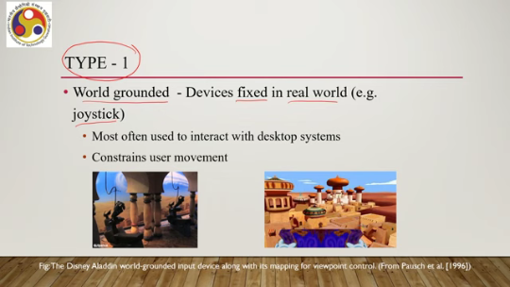
A user can control the environment using a joystick which has a fixed position in the real world. So, portability is an issue. But these are quite common, most often used to interact with desktop or systems that are also grounded. But the drawback is quite obvious that it constrains user movement.
So, the user has to move within a specified area. So, the first category is wild grounded input devices; an example is a joystick. Then category 2 or type 2 input is non-tracked handheld controllers. Now, these are held in hand, but not tracked in 3D space.
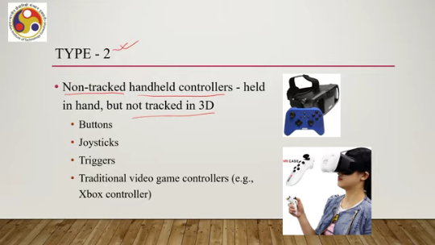
So, the system does not get to know where exactly the controller is with respect to a reference frame. Examples include buttons, joysticks, triggers, traditional video game controllers, and so on. Some examples are shown here in this figure. In the accompanying figure, as you can see, the controllers are shown. These are non-tracked handheld controllers.
Now, one issue with this type of controller can be the issue of break-in presence. What it means is that since the controllers are not tracked by the overall VR system, so user may be moving hands but does not get to see any corresponding change in position of the virtual hands in the virtual world. So, this actually creates some sort of discomfort in the mind of the user about whether they are actually performing the tasks appropriately or not. This is called break-in presence, or it affects the perception of presence in the virtual world.
So, the user does something but does not get to see the same thing in the virtual world. Then we have category 3, type 3 devices: hand input devices. These are tracked handheld controllers. So, earlier we talked about non-tracked controllers. Now, we are talking about tracked controllers.
The idea is very simple. These are devices with 6 degrees of freedom tracking. So, their movements can be tracked by the system. Input controllers that come with modern VR systems are tracked devices so that the break in presence is avoided. An example is VIVE controllers.
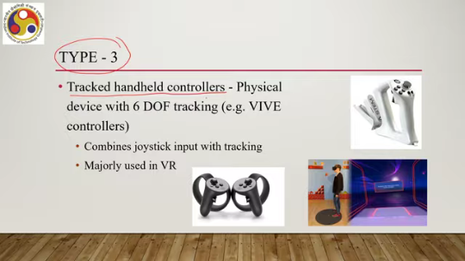
So, the controllers combine joystick with tracking. They are mainly used in VR. An example is shown here. Different examples are shown as you can see in the accompanying figure. However, there is one negative side to these tracked controllers as well.
Users are not able to directly or fully touch and feel other passive objects. So, if there are some objects in the virtual world and a user wants to get a feel of those objects, they will not be able to get that feeling through tangible interaction. Because their hands will be occupied with the controller. Sometimes force feedback controllers may resolve the issue, but that is one of the issues. Then we have type 4 hand input devices or the fourth category of hand input devices which are hand-worn devices, devices that are worn on the hands or arms.
Several such devices can be there, for example, gloves or data gloves, more popularly known as data gloves, then EMG bands, rings, and so on. So, these are all worn on the hand or arm or maybe finger. Now, among them, data gloves are more popular devices. There can be two types of data gloves. One is bend sensing gloves.
So, shown here in the accompanying figure as you can see, now it looks like a glove, but it detects hand postures and gestures because there are sensors placed at all bend positions or these joints and other positions. So, everywhere there are sensors, as you can see in the accompanying figure. So, all bend positions there can be sensors in a proper bend sensing glove and the processing unit receives continuous raw data from all these bend sensors and those are processed to detect the gesture.
So, it provides a large degree of freedom because so many sensors are there; any gesture is likely to generate different data streams for unambiguous interpretation. So, it provides a large degree of freedom, which makes the interaction more natural, likely to be more natural as compared to controller-based interaction. There is another type of data glove that is called pinch gloves. Unlike in the bend sensing glove, in pinch gloves, sensors are placed only at the fingertip positions, as you can see here in the accompanying figures, in these positions here.
They may not be on all the fingertips, but only maybe the thumb and the index finger fingertips. It may vary; the positions may vary, but only at very limited positions which are good at detecting some limited set of gestures that can occur due to pinch, or pinching gestures. So, typically these are used for discrete input such as object selection, mode switching, and so on. So, these types of data gloves are good at determining if the fingertips are touching, and from there it
Try to deduce the kind of command or gesture being provided. So, these are broadly two types of data gloves that are used with VR systems. Now, the advantages are quite obvious. Advantages of having such gloves or similar types of hand-worn devices, so natural input with potentially rich gesture interaction is possible.
Hands can be held in comfortable positions, no line of sight issue unlike some controller-based input. Hands and fingers can fully interact with real objects. So, they are free to interact with other real objects. thus making different sorts of perception possible. But there are also issues, although mostly they are good, but there are some other concerns like recognizing more than a few gestures requires the user to recalibrate often or relearn.
So, if we are supporting a large number of gestures to control a VR environment, those gestures users need to learn and remember which sometimes creates problems for different categories of users. Another problem is if the exposure time is long, then it may become uncomfortable wearing such gloves for a long duration, the hands may become sweaty and things will become uncomfortable. So, these are some of the negative sides, there are mostly positive sides. Then the last category or fifth category are the bare hand inputs.
So, here the system tracks the bare hand using computer vision techniques. These are the most natural interactions. Users do not need to wear anything. Users do not need to use any external device. They can simply provide gestures using bare hands.
And there are computer vision algorithms embedded into the system which can detect those gestures and accordingly translate them to commands in the virtual environment. So, the user's hands remain completely free. An example of such an input device can be the Leap Motion device. So, this is an IR or infrared-based sensor for hand tracking. So, it can work with HMD.
So, if we attach a Leap Motion device with HMD, then we will be able to provide hand input. to the user, hand input support to the user even if the HMD does not support hand input. So, typically the Leap Motion device comes with three IR LEDs and two wide-angle cameras and the LEDs generate IR lights picked up by the camera after getting reflected from the hands. Then the software component takes over the data and converts the signals into proper gestures for understanding the input. So, that is how this type of device works.
Typically useful when you are using a low-cost HMD which does not provide good quality controllers or does not come with controller support. Say, for example, you want to implement an experience with a cheap cardboard-type device where you will insert your smartphone to get the stereoscopic view. However, that type of device does not support interaction. So, you can attach a Leap Motion system to it to enable hand tracking with the cardboard-based experience.
But it has also got its problems. Not a perfect solution. Fatigue may occur from holding hands in front of a sensor or camera. It requires line of sight, so the hand should be in the line of sight of the camera. Consistent recognition of gestures across a wide range of users may be an issue and so on.
So, no approach is perfect. We have pros and cons for each of these hand-based input techniques. And depending on the situation, you have to choose which technique to use, which device to use. Now, that is on hand-based input mechanisms. Let us now move our attention to non-hand-based mechanisms or non-hand-based input devices.
As the name suggests, These types of devices capture input from other parts of the body other than the hand. Now, that can include head movement, eye gaze, voice, body movement and so on. So, different inputs can be considered. Accordingly, there can be different types of input devices, non-hand-based input devices.
So, let us discuss each of those quickly. So, the first one is category 1 or head tracking based input devices. These devices typically use our head motion for input as shown in this figure. So, the user is wearing an HMD which can double up as a head tracking device.
It has got sensors which can detect yaw, roll and pitch along different axes of the head movement and from there it can infer the kind of input that are coming and accordingly it can change the view. Then we have category 2 as eye trackers. Now these eye tracking devices typically come integrated with headsets as shown in this figure. It is an HMD with eye tracking support.
These are typically used to track eye movements, where the user is looking, how the eyes are moving, and based on that the system does. infers what to do and accordingly takes necessary action. So, these devices say eye tracker helps the system understand the user's eye movement. Now, eye tracking devices typically or eye tracking based input typically suffers from one important issue called Midas touch problem. So, when we say that we want to use eye tracker to control an environment.
then sometimes it is difficult to understand whether what the user is doing is intentional or by nature. Suppose we say that in our virtual world, we can select something by just looking at it. So, eye tracker can look, eye tracker can detect where we are looking, when we are looking. Now that looking can happen because we want to select that object or because we are habituated to occasional blank gazes. We are looking without any purpose.
Now it is difficult for the system to differentiate between the two. If the system detects that we are looking at a point, whether that is because we are giving it just a blank gaze or we are actually intentionally looking at that point to select an object. So, since the system is unable to differentiate, it may select objects when we are giving it a look, although originally the user did not want to select it. That is called Midas touch problem. Whenever we look, it gets selected or it gets some action done on it, although not all such gazes may be intentional.
So, people expect to look at things without that look meaning anything, which is general human behavior. However, the system may not be able to understand that behavior and may not be able to rectify the actions. So, eye tracker-based systems typically suffer from this issue. So, generally, it is not a good idea to use eye tracking alone as an input and use that to interact with the system.
Instead, it works better when other forms of input are also used. So, multimodal input is preferable over only eye tracking-based input. So, with that, we have come to the end of this part of the lecture. What we have learned here is that What is the broader idea of VR hardware?
We have to understand it from the overall system point of view, which comprises multiple components, not only the hardware part, and how those components interact with the hardware. Based on that, we know what the requirements are and what hardware to look for. So, we have got a comprehensive understanding of that. And based on that, we have identified three major hardware components of any VR system, namely input, output, and processor.
We are discussing input; we have talked about hand-based input, and we started our discussion on non-hand-based input, where we talked about head motion-based input and eye tracking-based input. We will continue our discussion on these non-hand-based input mechanisms in the subsequent part of the lecture. Also, in the next part of the lecture, we will be covering other components of the VR hardware. So with that, we conclude this part. Thank you.
Looking forward to seeing you in the next part of the lecture. Happy learning.

